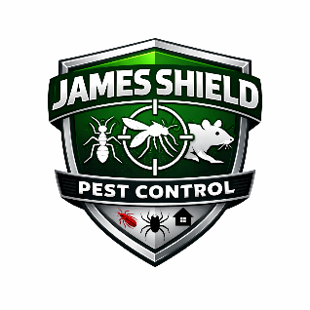

James Shield Pest Control
Chemical Spill Response & Cleanup Policy

1. Purpose
To establish procedures for safely responding to and cleaning up pesticide spills in order to protect employees, customers, the public, and the environment.

2. Immediate Response
If a spill occurs:
- Stop the source (if safe to do so).
- Secure the area to prevent exposure.
- Put on appropriate PPE immediately.
- Notify a supervisor.
If the spill is large or hazardous:
- Contact emergency services.
- Contact state environmental authorities if required.

3. Spill Classification
Minor Spill
- Small quantity
- No environmental threat
- Can be safely cleaned by trained employee
Major Spill
- Large quantity
- Threatens drains, soil, or waterways
- Requires emergency response
- Involves injury or exposure

4. Required Spill Kit Contents
All service vehicles and warehouses must carry:
- Absorbent materials (pads, clay, or granules)
- Chemical-resistant gloves
- Goggles
- Disposable coveralls
- Heavy-duty disposal bags
- Broom and dustpan
- Neutralizing agent (if required)
- Emergency contact sheet

5. Spill Cleanup Procedure (Minor Spills)
- Put on required PPE.
- Contain the spill using absorbent materials.
- Prevent product from entering drains or soil.
- Collect contaminated material.
- Place waste in labeled disposal container.
- Clean area according to label/SDS instructions.
- Wash hands thoroughly.
- Complete incident report.

6. Environmental Protection
Employees must never:
- Hose chemicals into storm drains.
- Dispose of pesticide waste in regular trash.
- Leave contaminated materials unsecured.
Waste must be disposed of according to state and federal regulations.

7. Reporting Requirements
Spills may require reporting to:
- State Department of Agriculture
- Environmental Protection Agency
- Local environmental authority
Management will determine reporting obligations.

8. Exposure Response
If chemical exposure occurs:
- Remove contaminated clothing immediately.
- Wash exposed skin with soap and water.
- Flush eyes for 15 minutes if exposed.
- Refer to SDS for first aid instructions.
- Seek medical attention if necessary.
- Complete exposure report.

9. Training
- All employees must receive spill response training annually.
- New employees must be trained before handling chemicals.

10. Documentation
All spills must be documented, including:
- Date and time
- Product name
- Estimated quantity
- Location
- Cleanup actions taken
- Reporting actions taken
Records must be maintained for a minimum of 3 years.
Approved By: _________________________
Date: ________________________________

